Region Management Functional Requirements

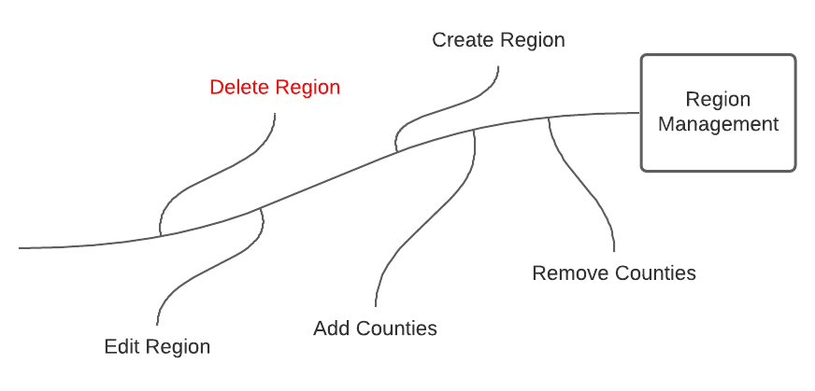

# Function Requirements

1. The system will allow Cartographers and Admins to add counties to a region.
2. The system will allow Cartographers and Admins to edit regions by removing or adding counties.
3. The system will allow region creators to name the defined region.
4. They system will have a display where Cartographers and Admins can see all the predefined regions created by all users.
5. The system will allow region creators to add a short descript about the defined regional area.
6. The system will track when the region was created, last updated, and who created it.
7. The system will allow region creators to delete defined regions they have created.

# County and Year Association for Counties Defined in a Region

Potentially, each year county names, FIPS codes, and data points can change. This creates a problem when defining a *Region of Counties* to use for a chart. If a county is nonexistent from a year that a data point is being used, this can create charting errors.

To avoid this potential error, while still allowing any CSV year to be associated with any count year, if a county is not in a specific year, they system will handle it as having no data. This will eliminate the use of tracking what year had specific counties across the United States.

In the case that a county was renamed or merged into another county, the region creator would need to add the old and new county. This would offset the chance of having no data while choosing a specific CSV year.